## https://www.facebook.com/ABA.Bank.Cambodia 0

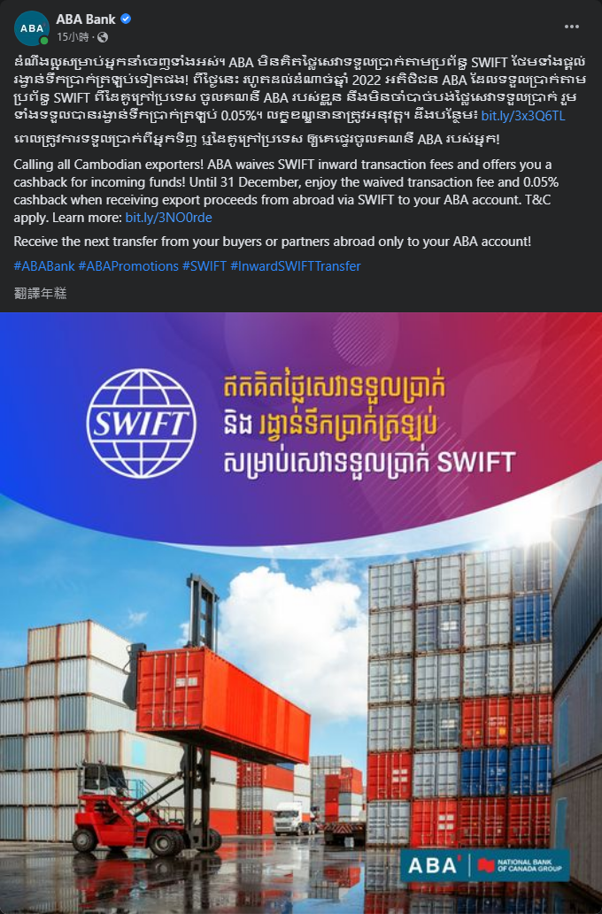

## https://www.facebook.com/ABA.Bank.Cambodia 1

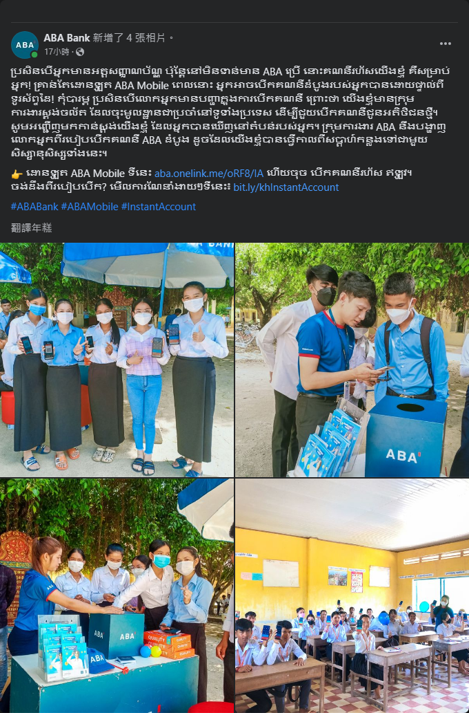

## https://www.facebook.com/ABA.Bank.Cambodia 2



## https://www.facebook.com/Maybank.KH 0



## https://www.facebook.com/Maybank.KH 1

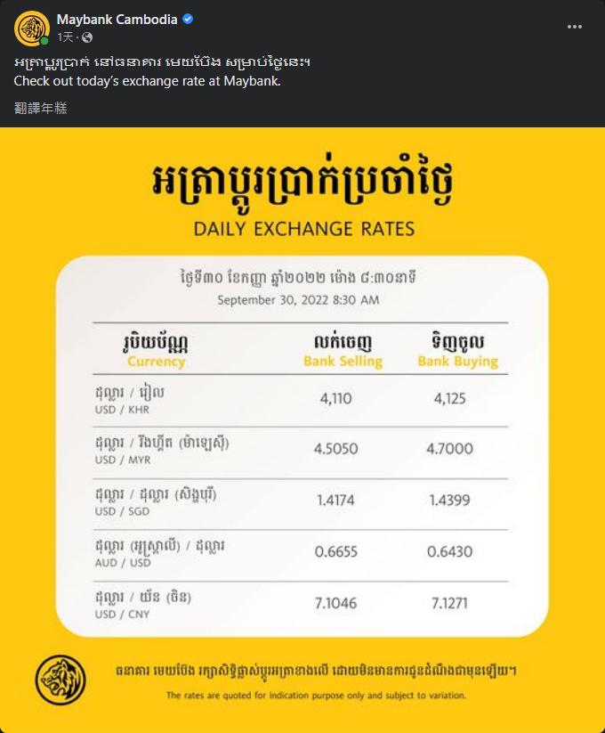

## https://www.facebook.com/Maybank.KH 2

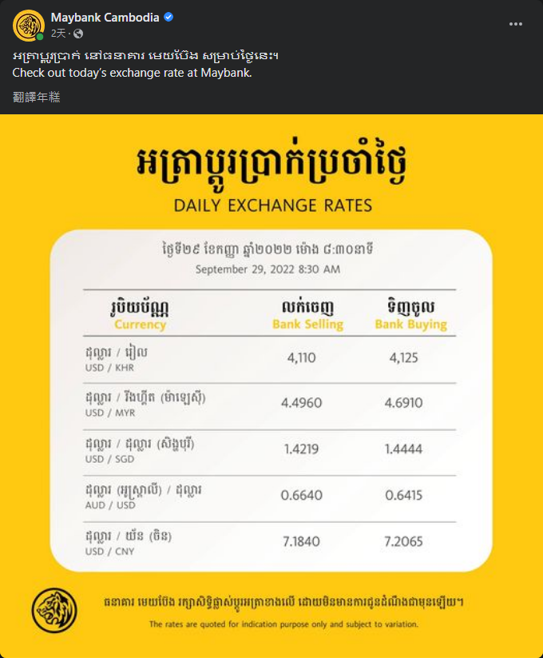

## https://www.facebook.com/CIMBCambodia 0

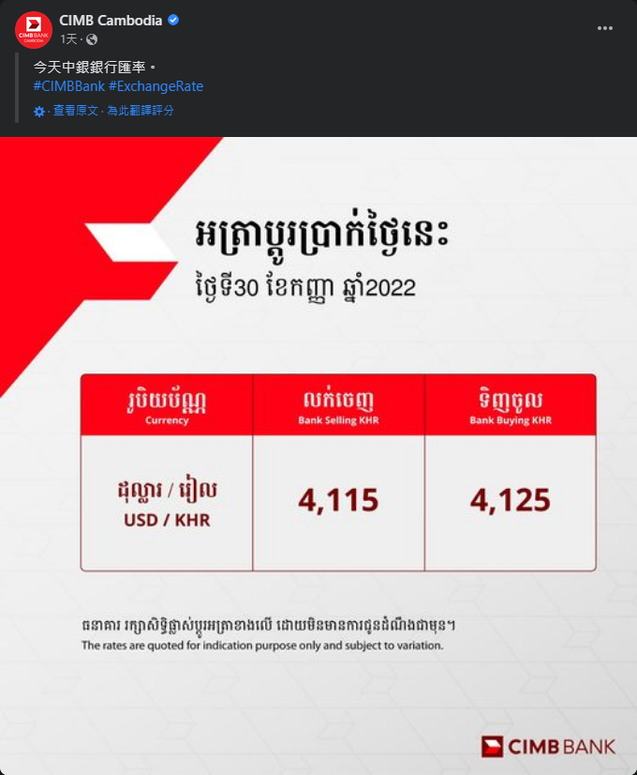

## https://www.facebook.com/CIMBCambodia 1



## https://www.facebook.com/CIMBCambodia 2

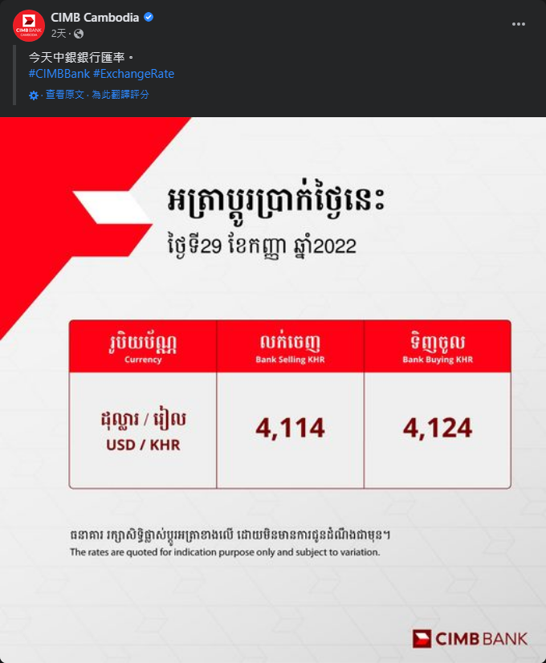

## https://www.facebook.com/publicbankkh 0



## https://www.facebook.com/publicbankkh 1

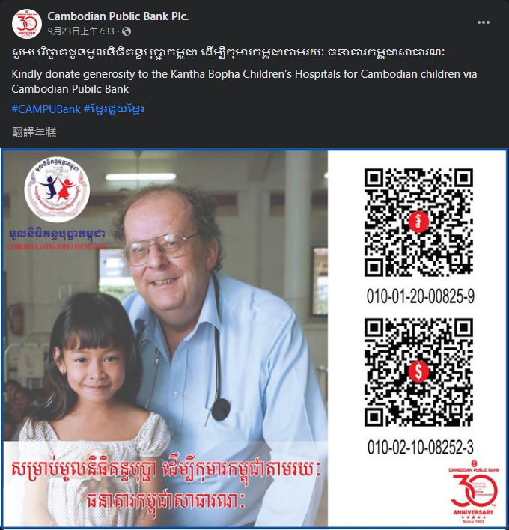

## https://www.facebook.com/publicbankkh 2

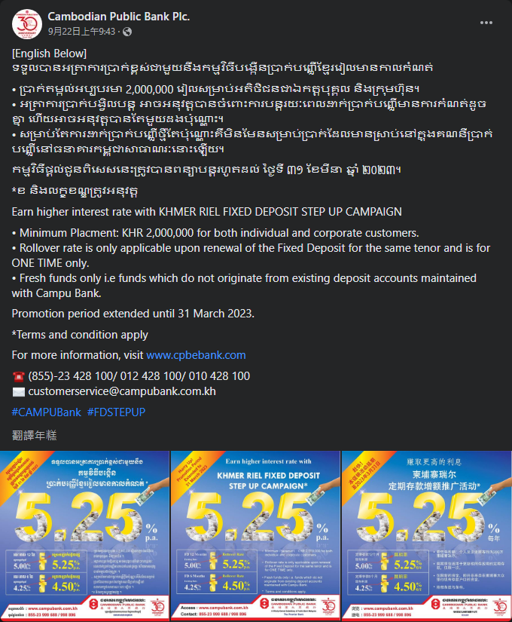

## https://www.facebook.com/jtrustroyalbank 0

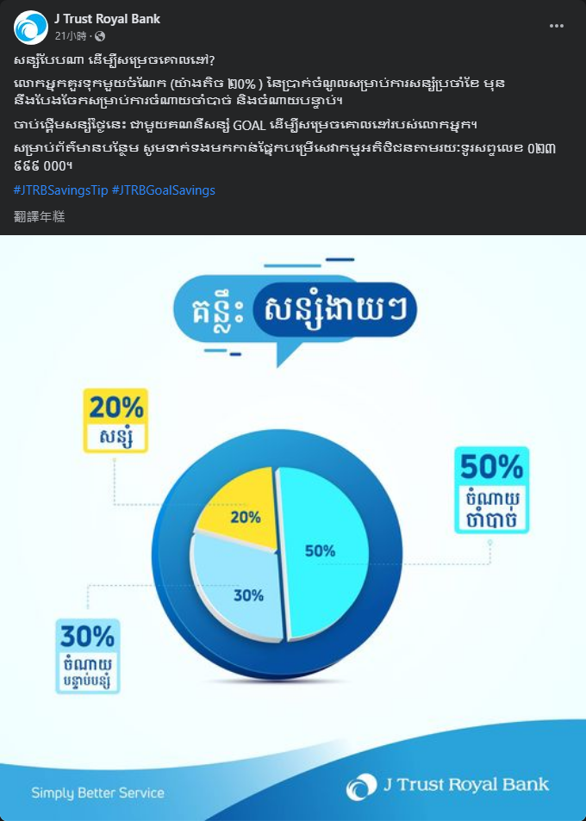

## https://www.facebook.com/jtrustroyalbank 1

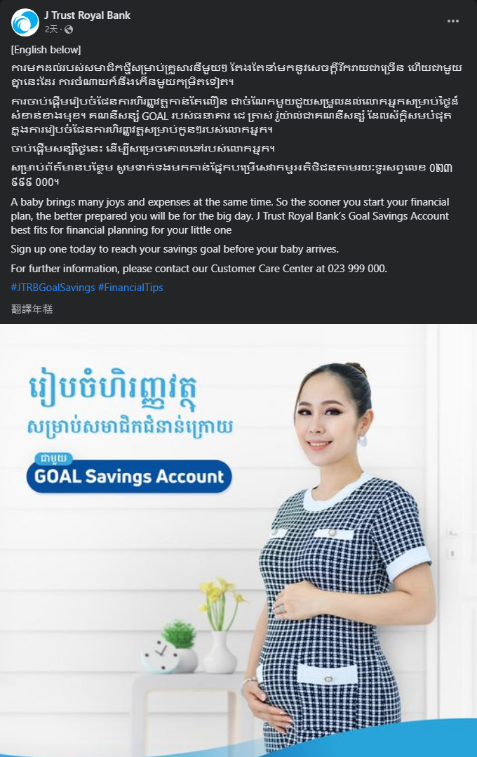

## https://www.facebook.com/jtrustroyalbank 2

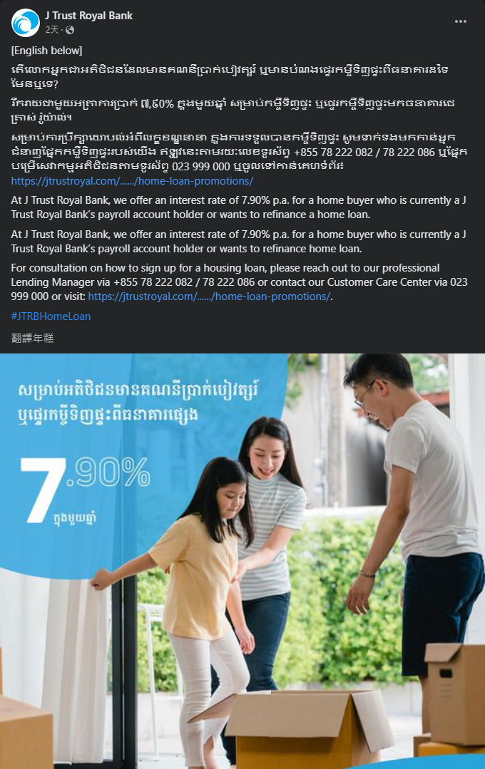

## https://www.facebook.com/Sathapanabank 0

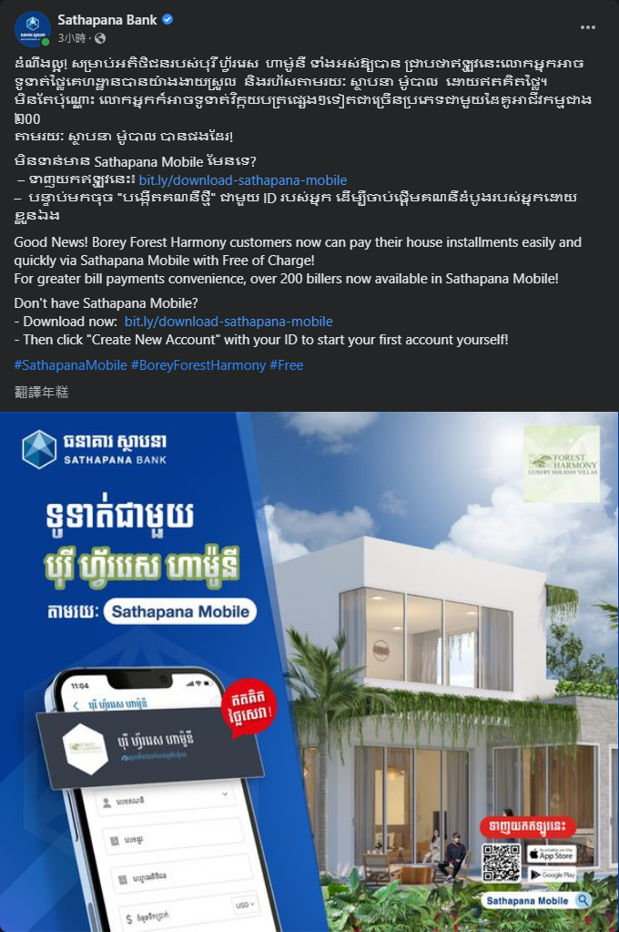

## https://www.facebook.com/Sathapanabank 1



## https://www.facebook.com/Sathapanabank 2



## https://www.facebook.com/groups/1897377573850793 0



## https://www.facebook.com/groups/1897377573850793 1

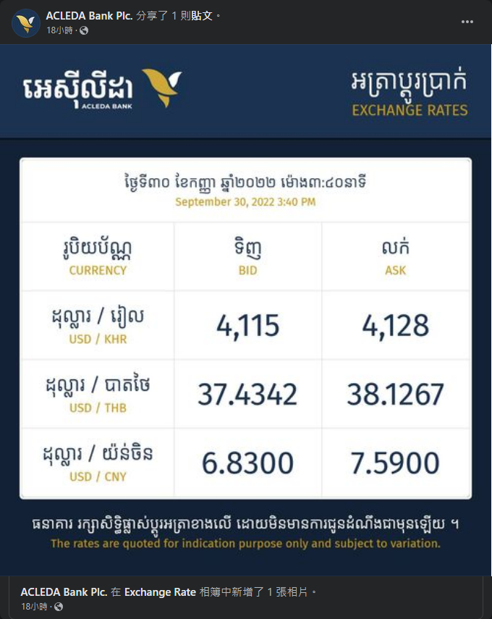

## https://www.facebook.com/groups/1897377573850793 2

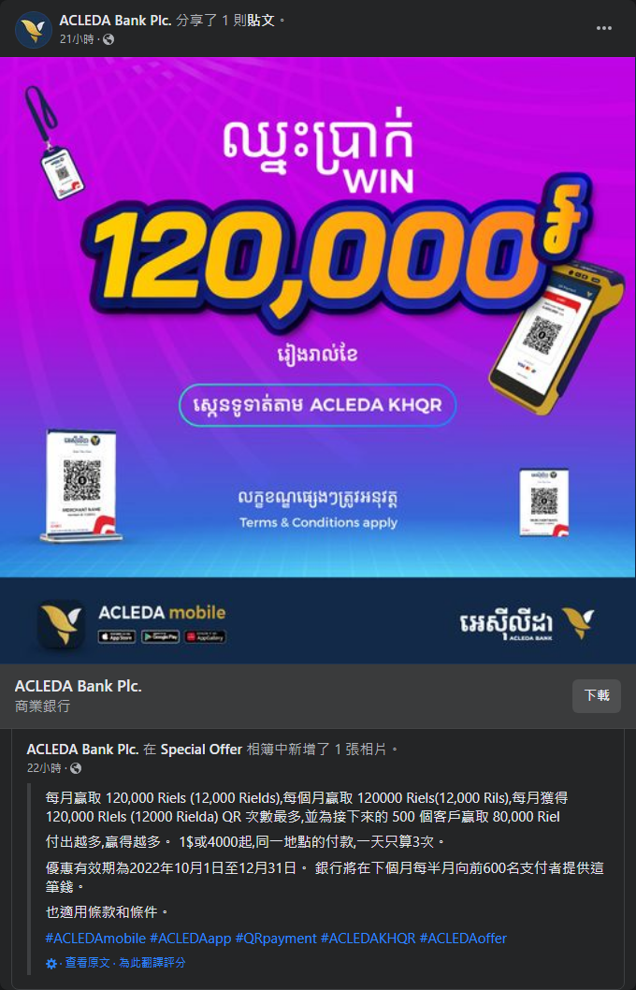

## https://www.facebook.com/CanadiaBankCambodia 0

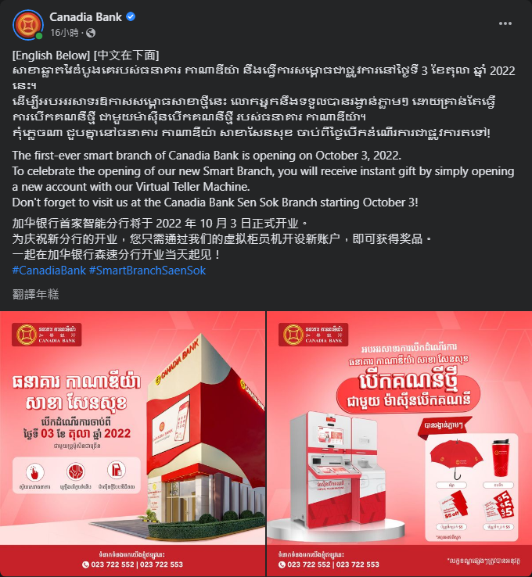

## https://www.facebook.com/CanadiaBankCambodia 1



## https://www.facebook.com/CanadiaBankCambodia 2

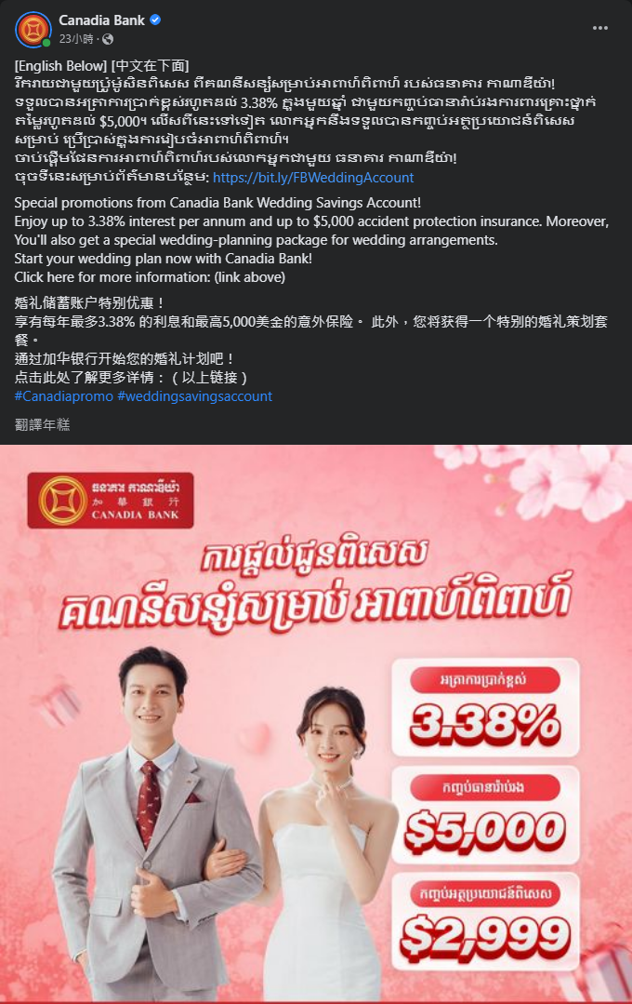

## https://www.facebook.com/kookminbankcambodiaofficial 0

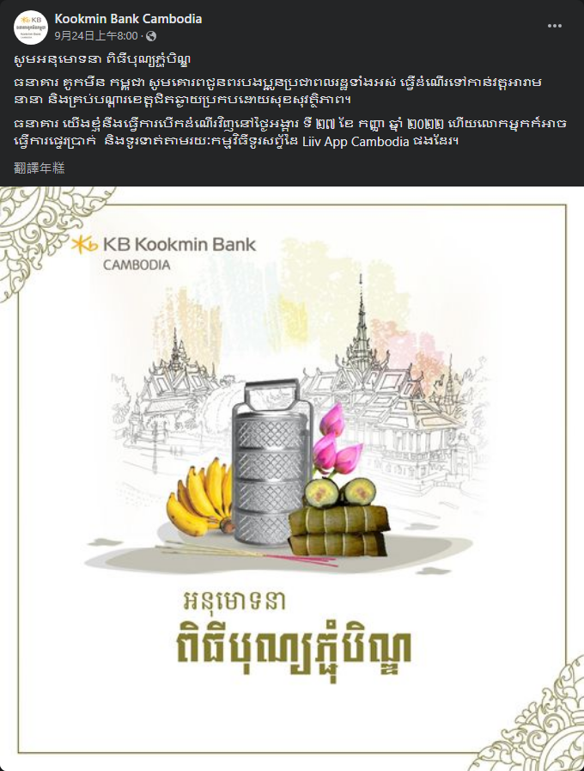

## https://www.facebook.com/kookminbankcambodiaofficial 1

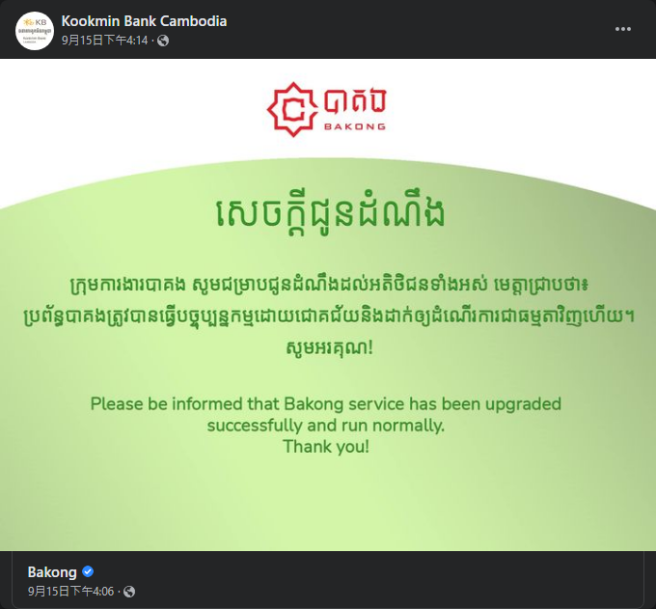

## https://www.facebook.com/kookminbankcambodiaofficial 2

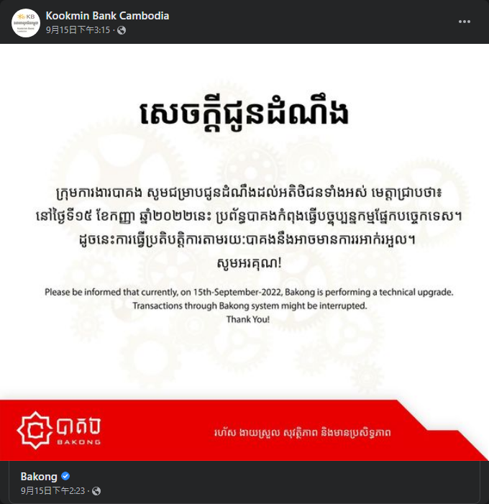

## https://www.facebook.com/shinhankmerbank.com.kh 0

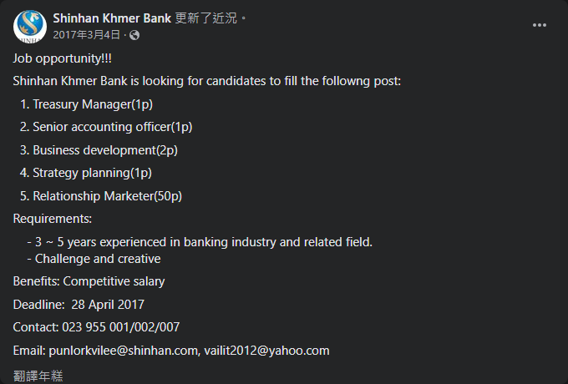

## https://www.facebook.com/shinhankmerbank.com.kh 1

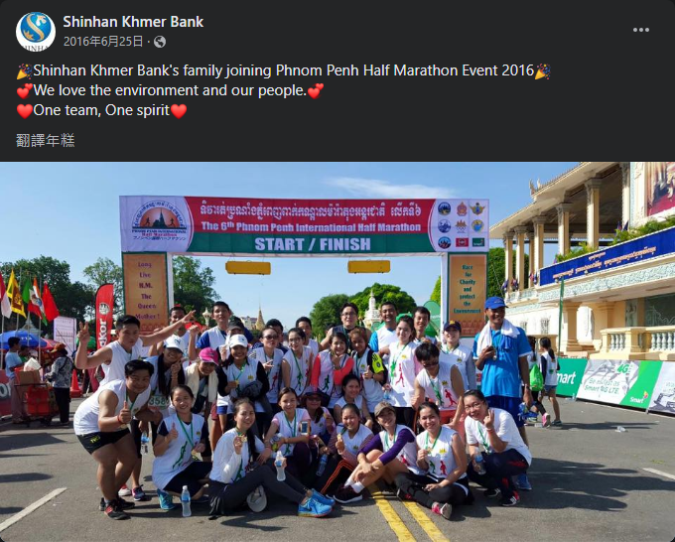

## https://www.facebook.com/shinhankmerbank.com.kh 2

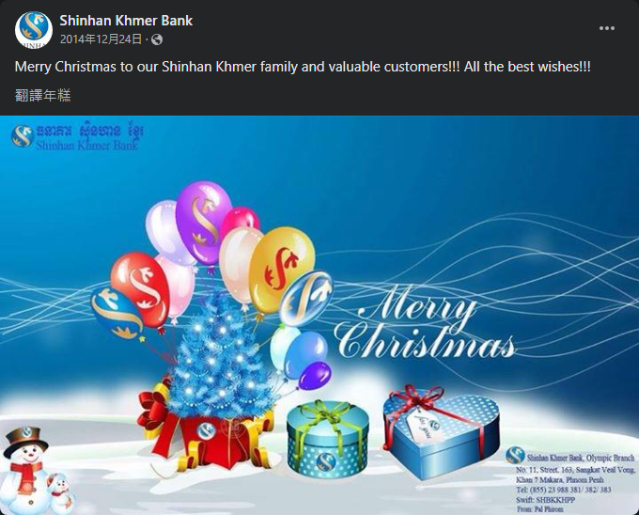

## https://www.facebook.com/BRED-Bank-Cambodia-1920063181403559 0

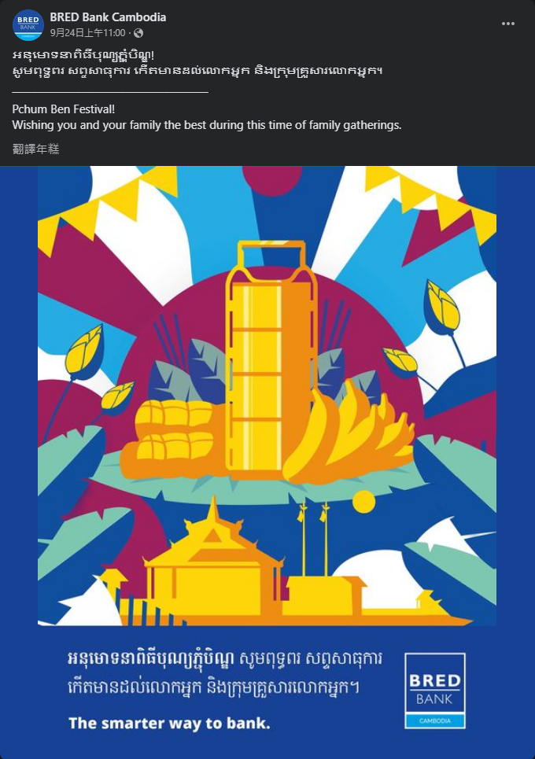

## https://www.facebook.com/BRED-Bank-Cambodia-1920063181403559 1

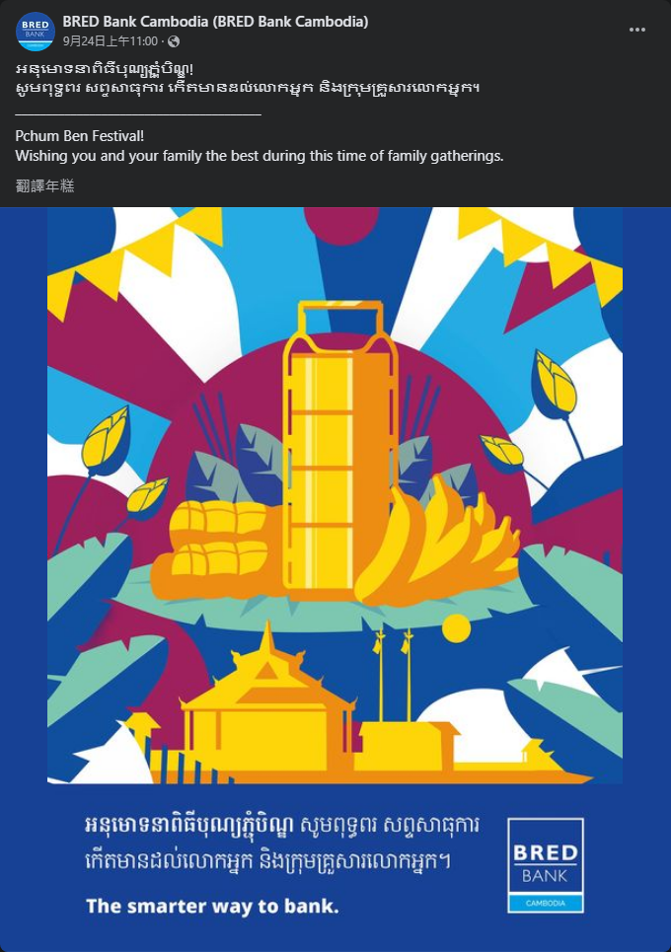

## https://www.facebook.com/BRED-Bank-Cambodia-1920063181403559 2

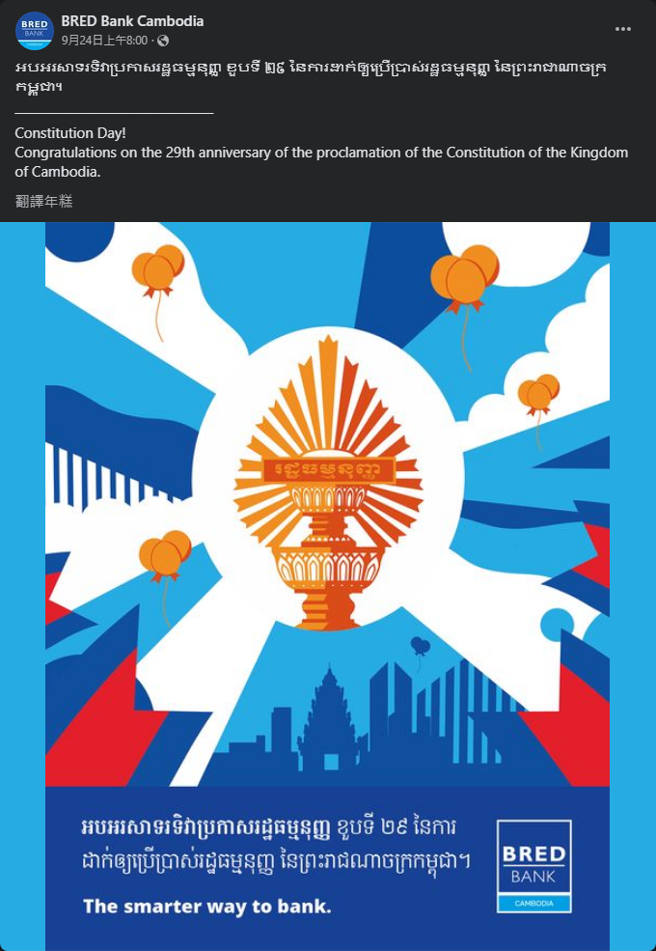

## https://www.facebook.com/WingBankKH 0

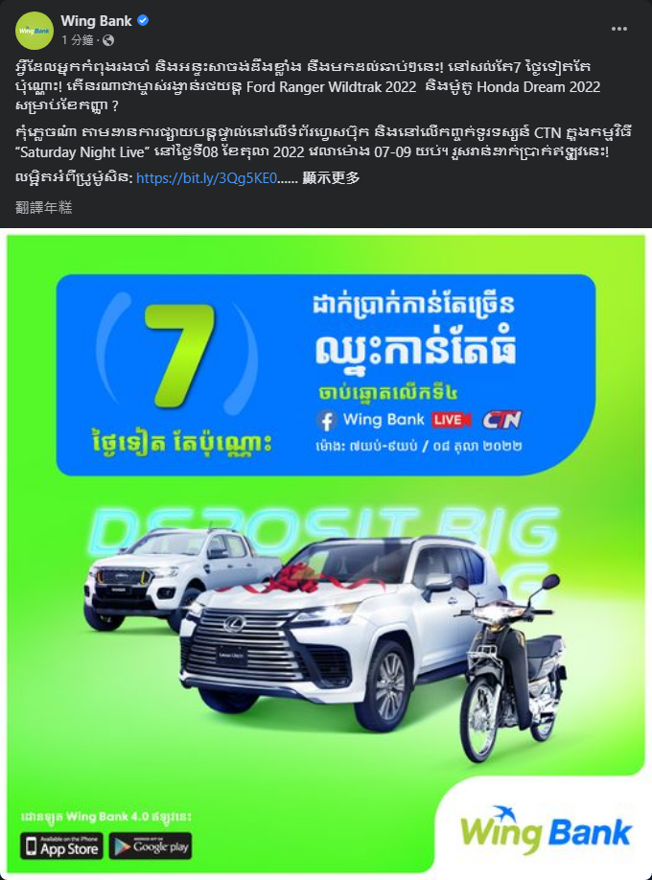

## https://www.facebook.com/WingBankKH 1

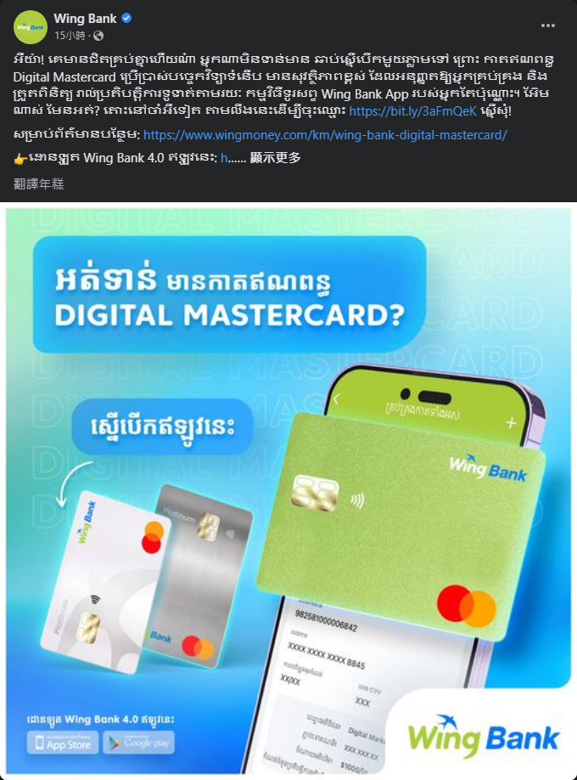

## https://www.facebook.com/WingBankKH 2

